**Centrifugal Pump Characteristics**

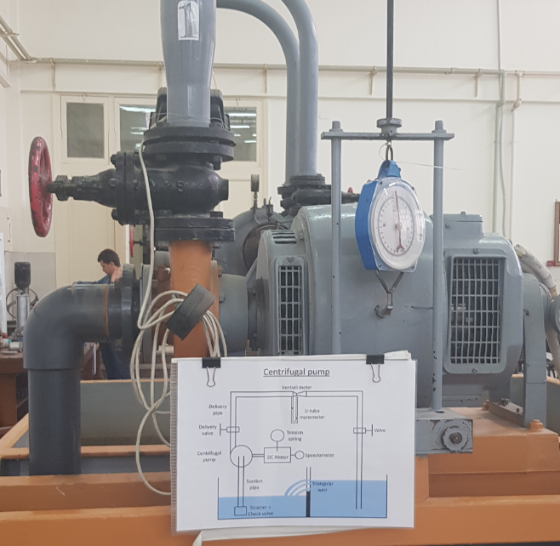

Centrifugal Pump

**Objective:-**

To study the performance of a centrifugal pump at different speeds.

**Procedure**

1-Operate the pump at a certain speed (N).

2- The discharge of the pump is changed using a gate valve installed on the delivery side.

3- Adjust the speed (N) for each case.

4-For different speeds (N) ,take the readings:-

*Manometric suction head (Hms) by using a pressure gauge, ft.

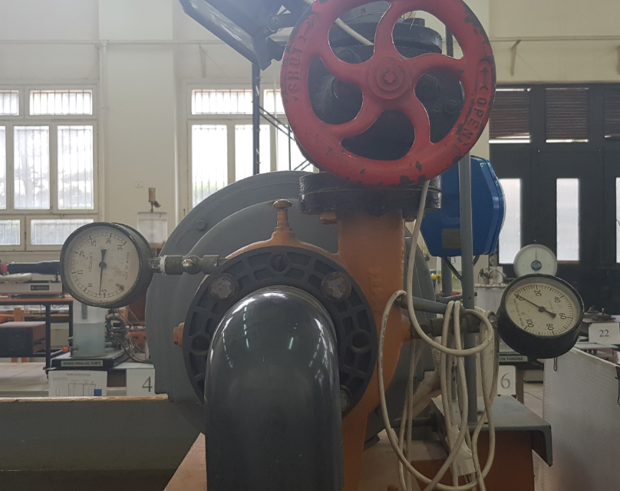

*Manometric delivery head (Hmd) by using a pressure gauge, ft.

*U-tube manometer reading(y), cm.

. *Force (F) by using weights, kgf

Pressure Guage

**Results (At N=2000RPM)**

|  |  |  |  |
| --- | --- | --- | --- |
| Ƞ | Input Power  (kW) | Head(m) | Flow rate Q (lit/s) |
| 0% | 0.25 | 13.1064 | 0 |
| 27.636% | 2.502 | 3.048 | 23.1524 |
| 20.681% | 2.502 | 2.1336 | 24.751 |
| 16.12% | 2.127 | 1.3716 | 25.513 |

1-The relation discharge (Q) and the pump manometric head (Hm)

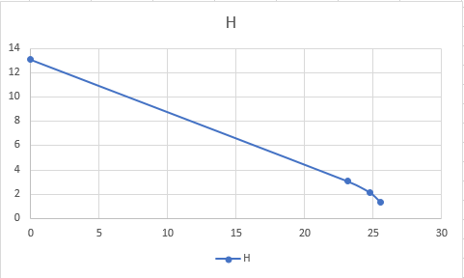

Q(lit/s)

Hm(m)

Hm(m)

2-Relation betweem The pump discharge (Q) and the pump input power (I/P)

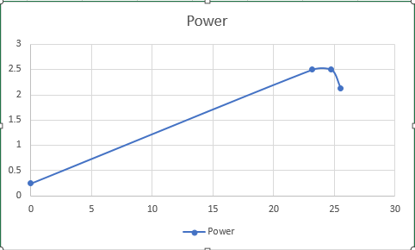

Q(lit/s)

I/p Power(kW)

Q 1

3-The relation between Flow rate (Q) and Efficiency

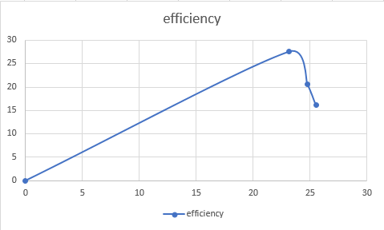

Q(lit/s)

Ƞ

**Results (At N=2500RPM)**

|  |  |  |  |
| --- | --- | --- | --- |
| Efficiency % | Input Power(kW) | Head(m) | Flow rate Q (lit/s) |
| 0% | 1.564 | 23.1648 | 0 |
| 40.3456% | 5.591 | 8.5344 | 26.972 |
| 17.54% | 5.552 | 3.5052 | 28.3558 |
| 3.46% | 5.552 | 0.6096 | 32.1525 |

1-Relation between the pump discharge (Q) and the pump manometric head (Hm)

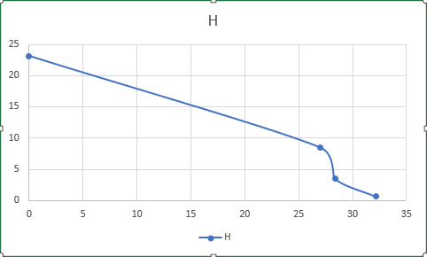

Q(lit/s)

Hm(m)

2- Relation between The pump discharge (Q) and the pump input power (I/P)

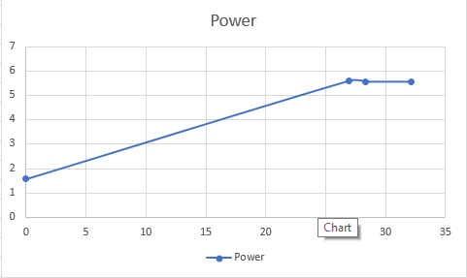

Q(lit/s)

I/p Power(kW)

3-The relation between Flow rate (Q) and Efficiency (η):

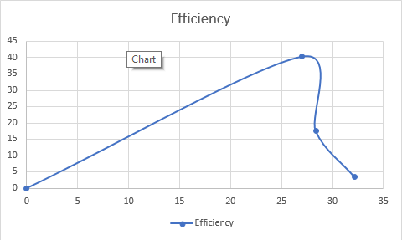

Ƞ

Q(lit/s)

.

*Relation between Flow rate and Head at N1 and N2:

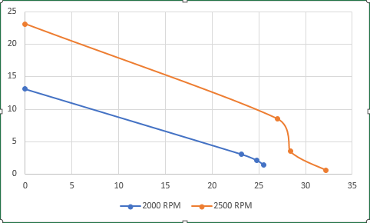

Q(lit/s)

Hm(m)

*Relation between Flow rate and i/p Power at N1 and N2:

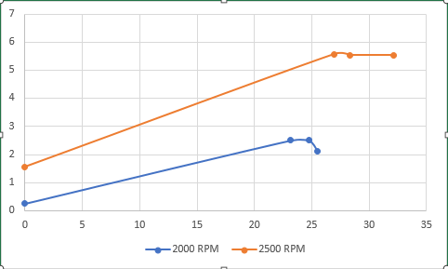

Q(lit/s)

I/p Power(kW)

*Relation between Flow rate and η at N1 and N2:

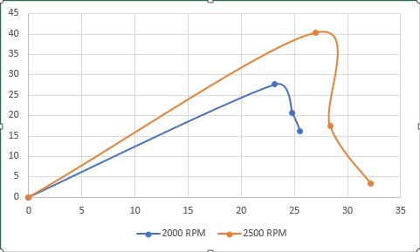

Ƞ

Q(lit/s)

Calculations:

1. Pump manometric Head:

Hm = Hmd - Hms

1. Discharge:



Where:

Cd = 0.94

dpipe = 10 cm

dthroat = 6.86 cm

y = U-tube manometer reading

1. Efficiency:

η = (O/P) / (I/P)

Where,

O/P = water x Hm x Q

I/P = T x ω

T = F x R

ω = 2π N / 60

R (brake radius) = 0.3048 m.